**Lab 2**Q13:

Q14:  
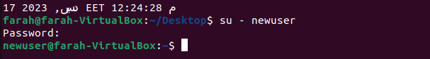  
Q15:  
Q16:  
1-  
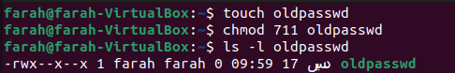

2-

3-By default, when a file is created, it usually gets permissions of 666 (read and write for owner, group, and others). For a directory, the default is typically 777 (read, write, and execute for owner, group, and others).  
4-

Q17:

1- copy directory  
Permission for the source directory: Read and Execute (r-x)

Permission for the target parent directory: Write (w)  


2- copy file  
Permission for the source file: Read (r)

Permission for the target parent directory: Write (w)

3- delete file  
Permission for the file itself: Write (w)

Permission for the directory containing the file: Write (w)

4- change to a directory  
Permission for the directory: Execute (x)  
  
5-list a directory content (ls command)  
Permission for the directory: Read (r)

6- view a file content (cat command):

Permission for the file: Read (r)

7- modify a file content:

Permission for the file: Write (w)

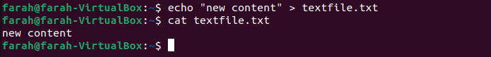  
Q18:

Q19:

For files, the "x" permission allows execution of the file

For directories, the "x" permission allows access to the contents of the directory

